
Comsats University Islamabad, Lahore Campus

Theory Assignment <2> – SPRING 2025
Course Title | Software Testing | Course Code |  | CSE455 | Credit Hours |  |  | 3(2,1)
Instructor/s | Ms. Yella Mehroze | Program Name |  | BSSE
Semester | 8th | Batch | FA21 | Section | A | Date | March 23, 2025
Time Allowed | 1 week | Maximum Marks
Student Name/s | Aoun-Haider, Talha-Shafique | Reg No. |  | FA21-BSE-133, FA21-BSE-152

Question Statement [CLO-2]; Bloom Taxonomy Level: <Applying>
Illustrate the following concepts and relate examples with your final year projects.
DESCRIPTION
1. Test Basis
2. Test Object
3. Test Item
4. Test Conditions
5. Test Execution Schedule
6. Test Suite
7. Test Script
8. Test Log
9. Test Plan
Solution
- Test Basis: Consists of documents, requirements and artifacts that provide information about what needs to be tested. It helps in defining test cases and conditions.
For example: Software requirement specification (SRS) document acts as a test basis for our FYP.
- Test Object: is the system or component being tested.
For example: The Timber Trails game is the test object in our FYP project. Specific components of the game are Main Menu, Player Movement, Combat System, and Inventory Management.
- Test Item: is a specific part of the component that is being tested.
For example: Main Menu Navigation test item include Loading Screen, Player movement controls, Zone transitions, Power-up collection
- Test Conditions: is a specific requirement or scenario to be tested to ensure the application functions correctly.
For Example: In our FYP, test condition is “Verify that the player can jump when pressing the spacebar”. Other test conditions are:
- The game should load within 15 seconds.
- Player should be able to equip weapon from the inventory.
- Test Execution Schedule: is a timeline that defines when specific test cases should be executed.
For Example:
Week 1: Test game loading & main menu
Week 2: Test player movement and combat mechanics
Week 3: Test zone progression & inventory system
Week 4: Perform final system testing before submission
- Test Suite: is a collection of test cases grouped together based on functionality.
For Example: Possible test suites in our FYP can be:
Player Movement:
Test Case 1: Moving forward/backward
Test Case 2: Jumping over obstacles
Test Case 3: Sprinting using shift key
Combat System:
Test Case 1: Attacking enemy
Test Case 2: Using a shield to block attacks
Test Case 3: Losing health when win
- Test Script: Steps to be followed while execute a test case in a test cycle.
For Example: Test Suite for Collecting Power-ups
- Start the game and enter the Zone 1
- Locate a power-up item on the ground
- Move the player towards the item and press ‘E’ to pick it up
- Open the inventory and verify that item is added
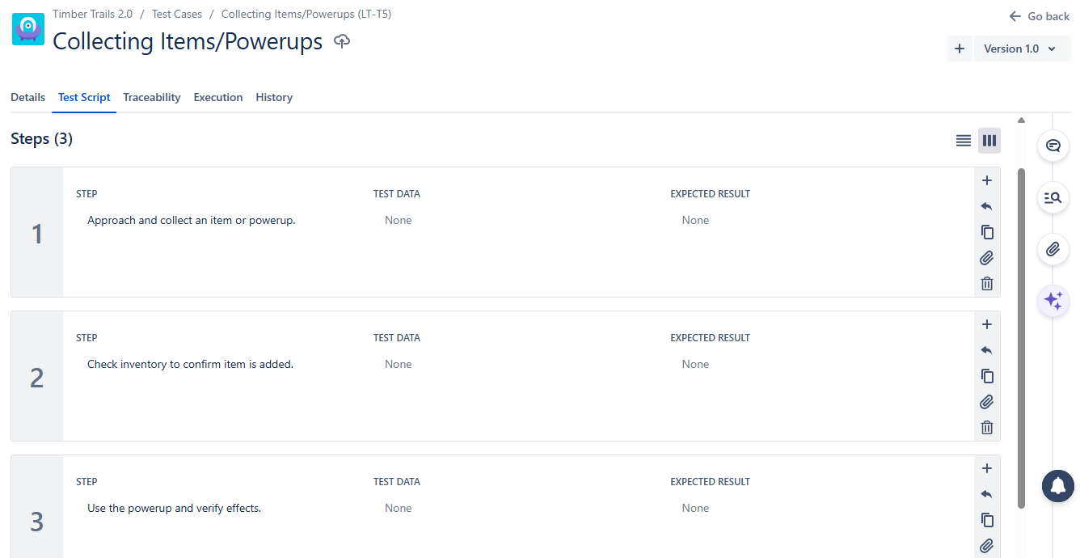
Fig-1: Test Script for Collecting power-ups in Jira

- Test Log: is a record of test execution results, including passed, failed, or blocked test cases.
For Example: Sample test log from Jira project is:
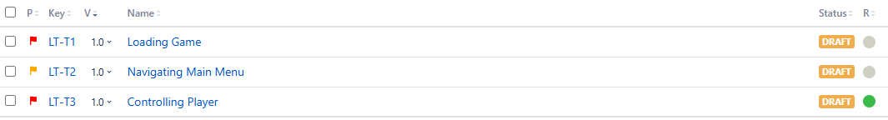
Fig-2: Test Cases with their execution status

- Test Plan: is a document outlining the testing scope, resources and schedule.
For Example: Test Plan created for our FYP project from Jira project is:

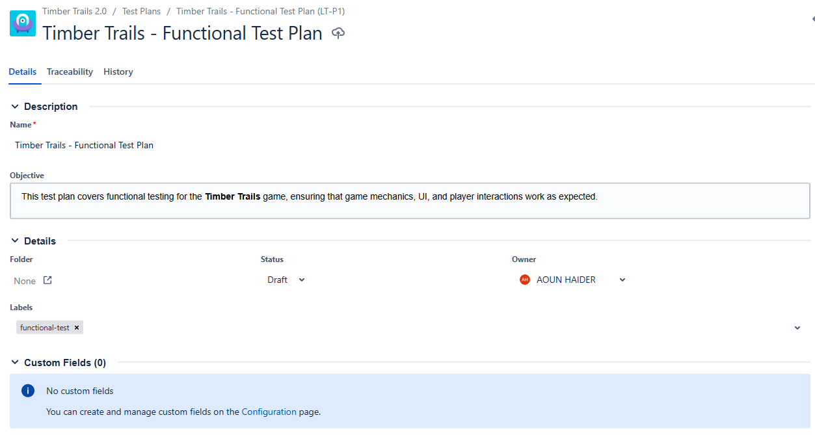
Fig-3: Test Plan for Functional Testing

Objective | Verify core functionality of sprint-1
Scope | Functional testing on Windows 11
Testers | Mr. Aoun Haider, Talha Shafique
Test Execution Dates | April 25, 2025
Exit Criteria | All critical defects fixed, 90% test cases must pass

